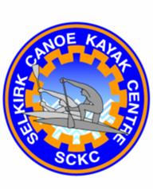
SELKIRK CANOE KAYAK CENTRE
Box 404, Selkirk, MB, R1A 2B3
Location: Selkirk Park (along Dyke Road past the Skateboard Park)
Club House phone (204-785-2054)

email: selkirkkayak@hotmail.com

Paddling Opportunities for ALL ages!
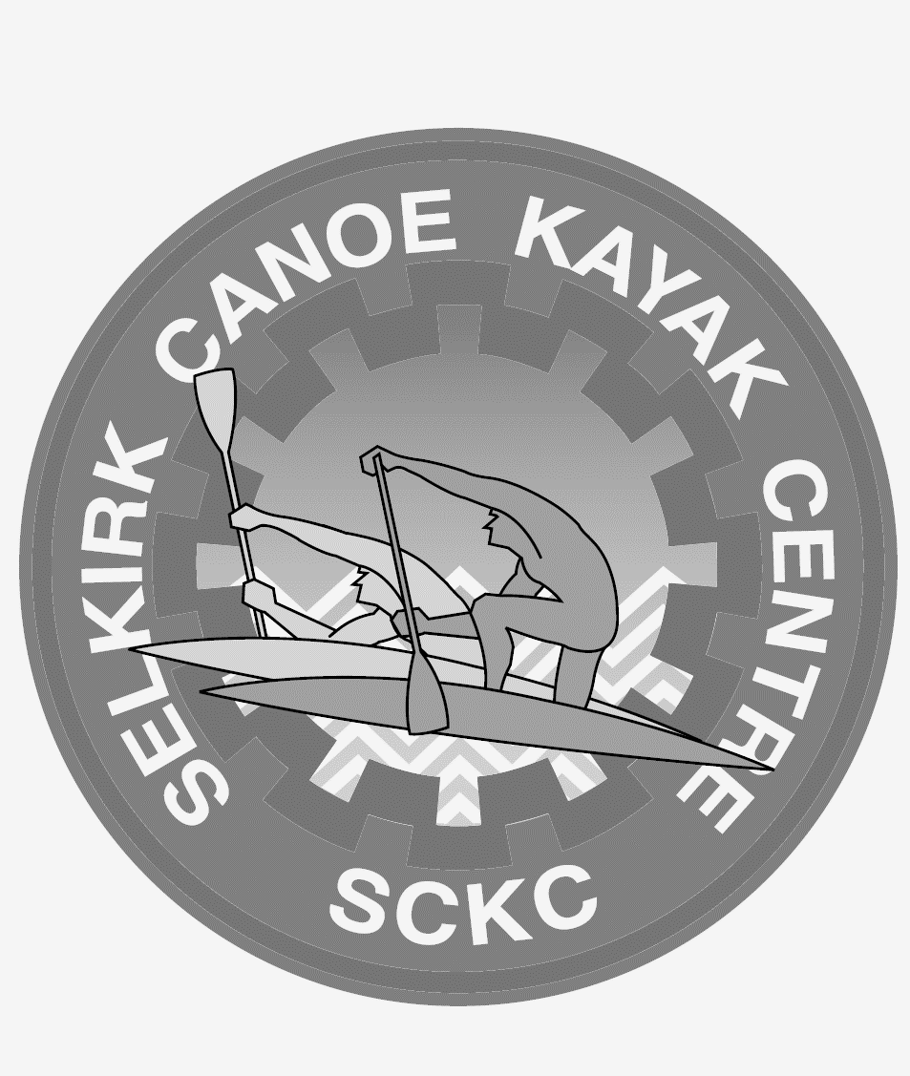
Canoeing, kayaking, dragon boating, & paddle boarding

Permitted access to all boats for members during supervised hours.

Season runs from May to September 2017

Hours: Monday to Friday evenings 4:00pm – 8:00pm

- Drop in: $10/person $20/family

- Adult: $100/season

- Family: $300 per family of 3 or more

- Kiddy: (ages 6 to 8): $100/child for season (Adult must be present)

- Youth Program: (ages 9 – 16): $100/person for season

- Summer Sport Camps: $100 per camp
Dates: July 10th–14th and August 14th–18th
(Registration for camps includes pass for the season)

Participants must bring a bag lunch, snacks, water bottle, weather appropriate clothing, change of clothing, towel, sandals, runners, sunscreen & hat.

Early drop off & early pick-up available - extra $25.00 per week (no drop off prior to 8:00am or after 5:00pm)

Advance Registration Required for Camps

- Competitive Dragon Boat/Canoe/Kayak Events or Tours: separate registration & fees are required

- Storage: $50/month or $200/year per boat

